**Advance Coding**

**Week 1**

Sanjay Chandagani - VU21CSNE0300372

**1. Program to calculate sum of digits of a number**

#include <stdio.h>

int main() {

int num, sum = 0;

printf("Enter a number: ");

scanf("%d", &num);

while (num != 0) {

sum += num % 10;

num /= 10;

}

printf("Sum of digits: %d\n", sum);

return 0;

}

**Output:**

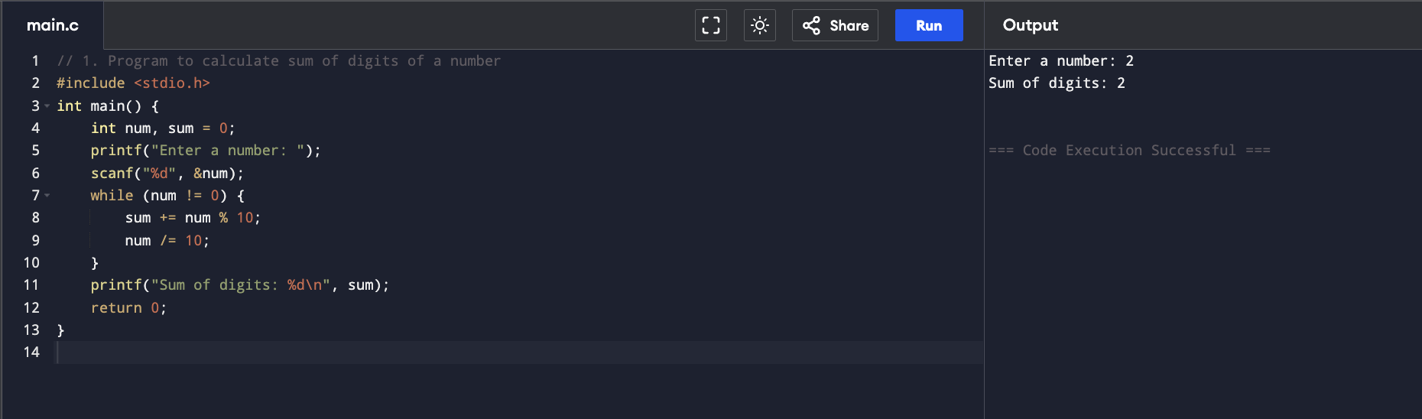

**2. Program to find first and last digit of a number**

#include <stdio.h>

int main() {

int num, first, last;

printf("Enter a number: ");

scanf("%d", &num);

last = num % 10;

while (num >= 10) {

num /= 10;

}

first = num;

printf("First digit: %d, Last digit: %d\n", first, last);

return 0;

}

**Output:**

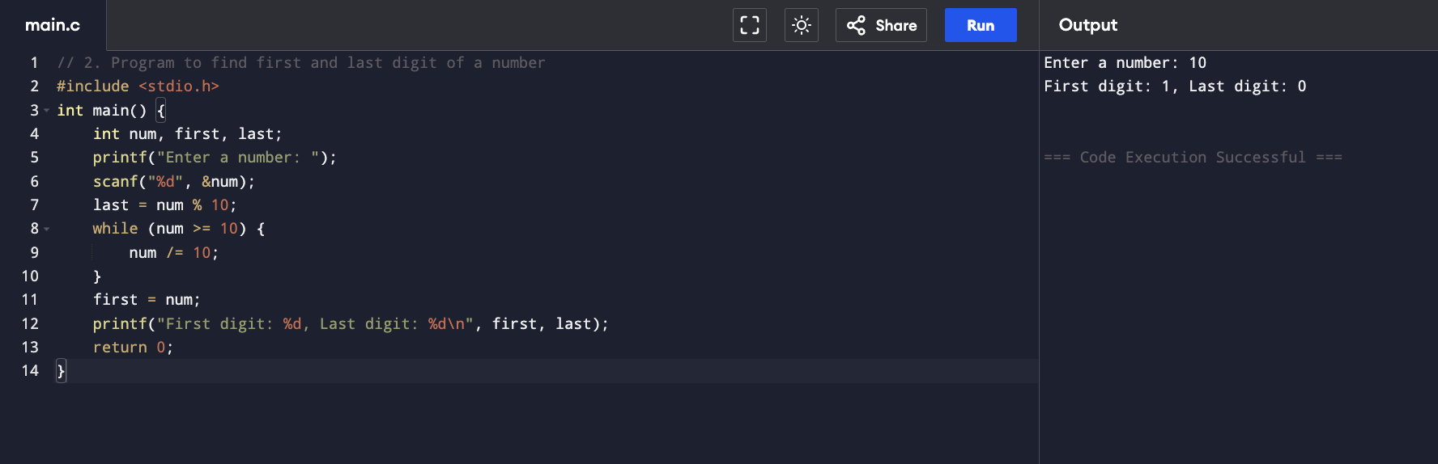

**3. Program to find sum of first and last digit of a number**

#include <stdio.h>

int main() {

int num, first, last;

printf("Enter a number: ");

scanf("%d", &num);

last = num % 10;

while (num >= 10) {

num /= 10;

}

first = num;

printf("Sum of first and last digit: %d\n", first + last);

return 0;

}

**Output:**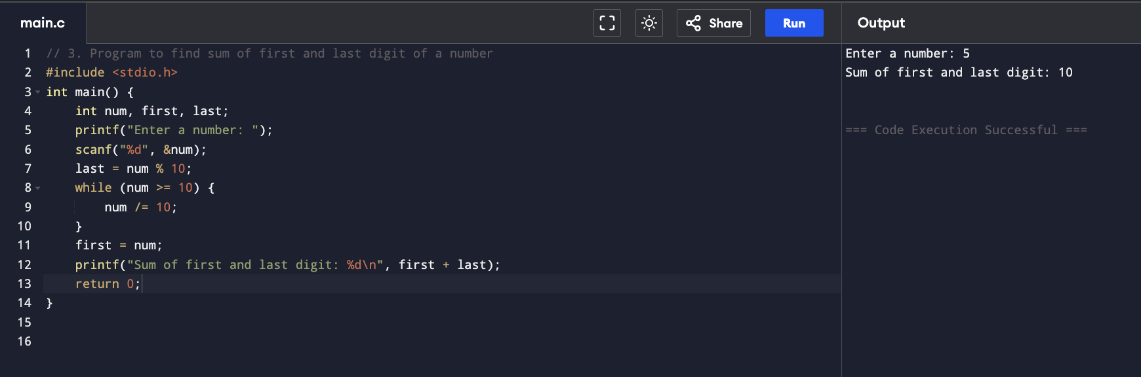

**4. Program to swap first and last digits of a number**

#include <stdio.h>

#include <math.h>

int main() {

int num, first, last, digits, swappedNum;

printf("Enter a number: ");

scanf("%d", &num);

digits = (int)log10(num);

first = num / (int)pow(10, digits);

last = num % 10;

swappedNum = last * (int)pow(10, digits) + (num % (int)pow(10, digits)) / 10 * 10 + first;

printf("Number after swapping first and last digits: %d\n", swappedNum);

return 0;

}

**Output:**

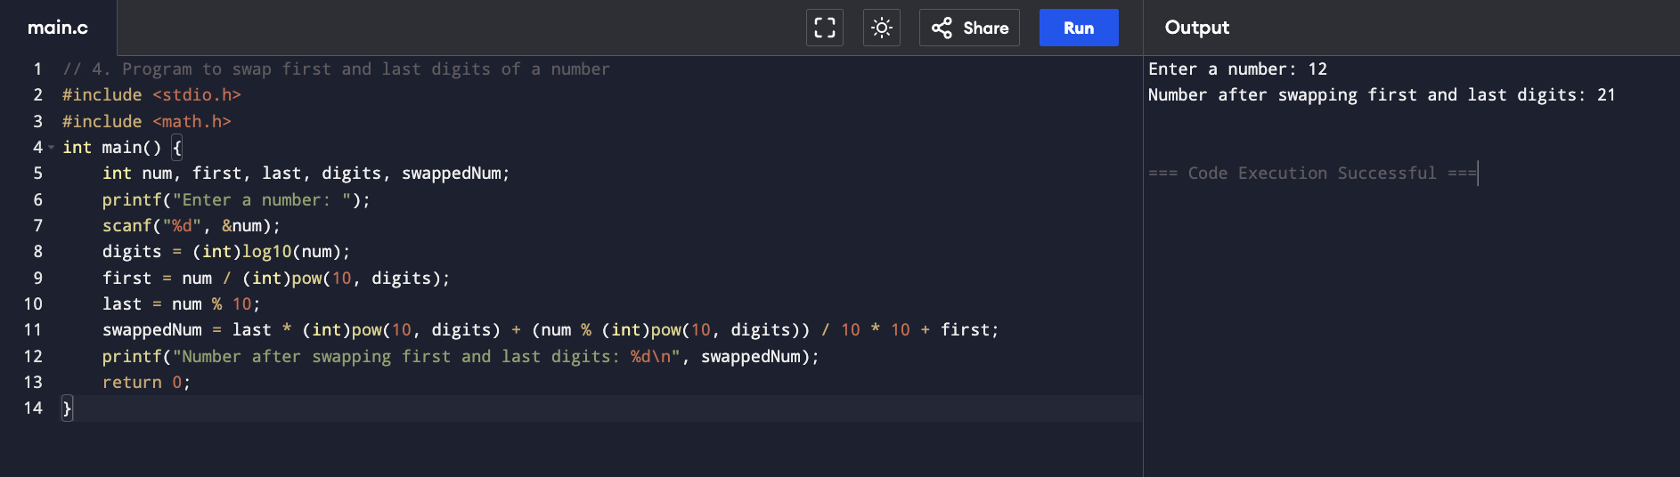

**5. Program to find frequency of each digit in a given integer**

#include <stdio.h>

int main() {

int num, digit, frequency[10] = {0};

printf("Enter a number: ");

scanf("%d", &num);

while (num != 0) {

digit = num % 10;

frequency[digit]++;

num /= 10;

}

printf("Digit frequencies:\n");

for (int i = 0; i < 10; i++) {

if (frequency[i] > 0) {

printf("%d: %d\n", i, frequency[i]);

}

}

return 0;

}

**Output:**

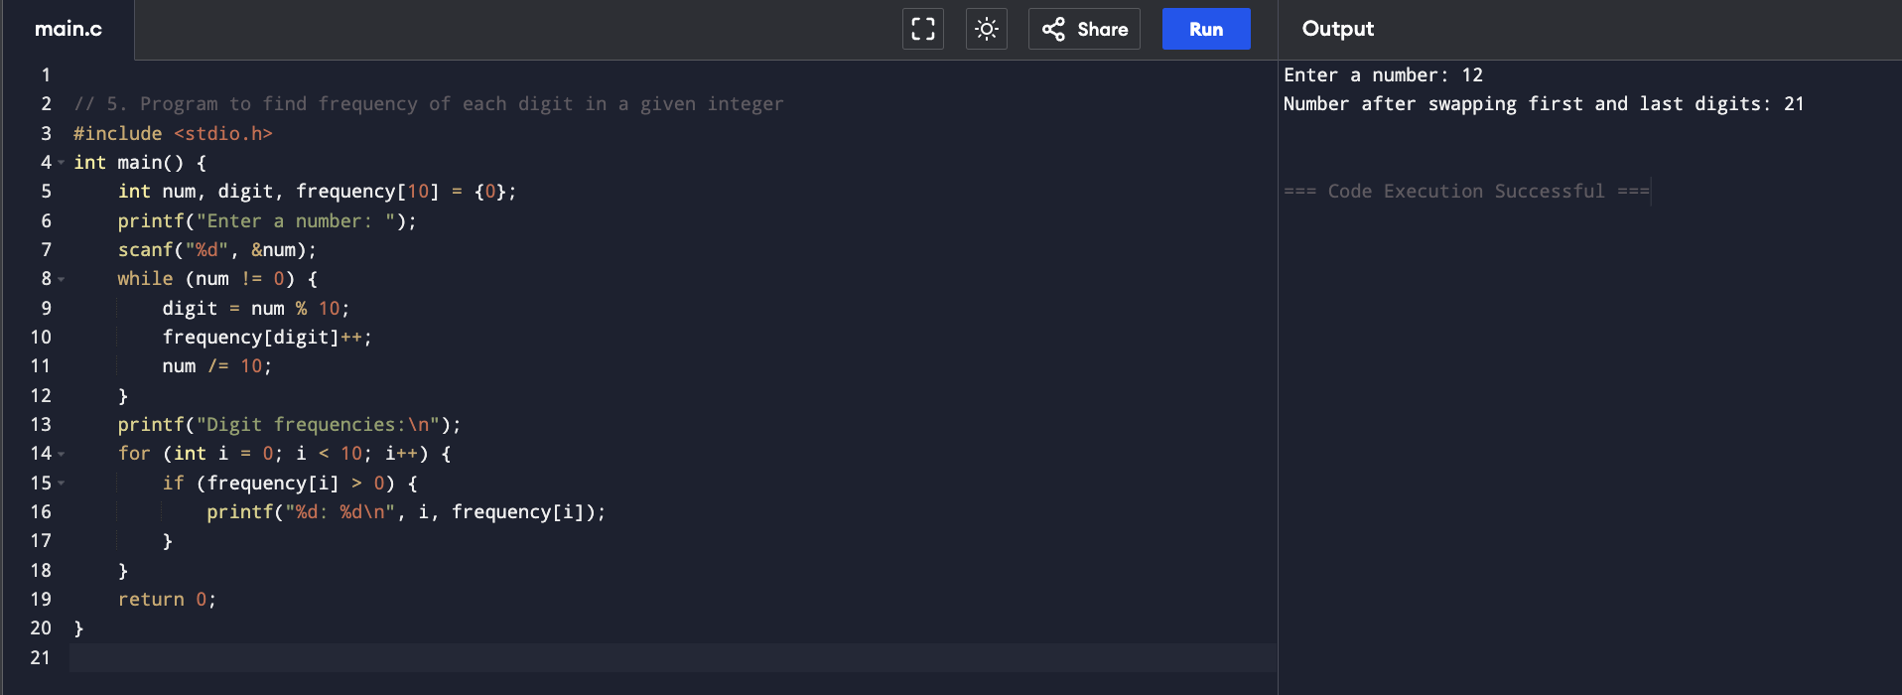

**6. Program to enter a number and print it in words**

#include <stdio.h>

void printWords(int num) {

if (num == 0)

return;

printWords(num / 10);

switch (num % 10) {

case 0: printf("Zero "); break;

case 1: printf("One "); break;

case 2: printf("Two "); break;

case 3: printf("Three "); break;

case 4: printf("Four "); break;

case 5: printf("Five "); break;

case 6: printf("Six "); break;

case 7: printf("Seven "); break;

case 8: printf("Eight "); break;

case 9: printf("Nine "); break;

}

}

int main() {

int num;

printf("Enter a number: ");

scanf("%d", &num);

if (num == 0)

printf("Zero");

else

printWords(num);

printf("\n");

return 0;

}

**Output:**

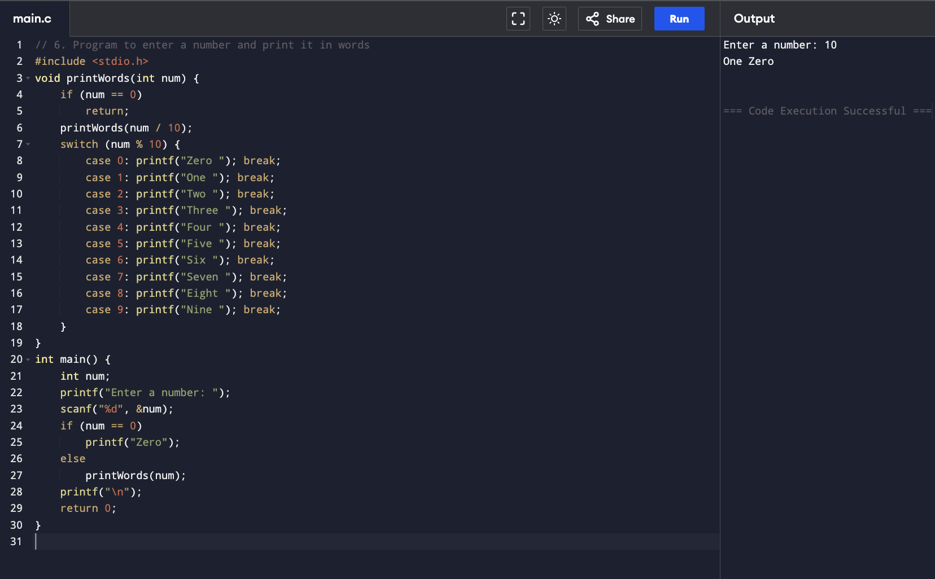

**7. Program to find one’s complement of a binary number**

#include <stdio.h>

#include <string.h>

int main() {

char binary[32];

printf("Enter a binary number: ");

scanf("%s", binary);

printf("One's complement: ");

for (int i = 0; binary[i] != '\0'; i++) {

printf("%c", binary[i] == '0' ? '1' : '0');

}

printf("\n");

return 0;

}

**Output:**

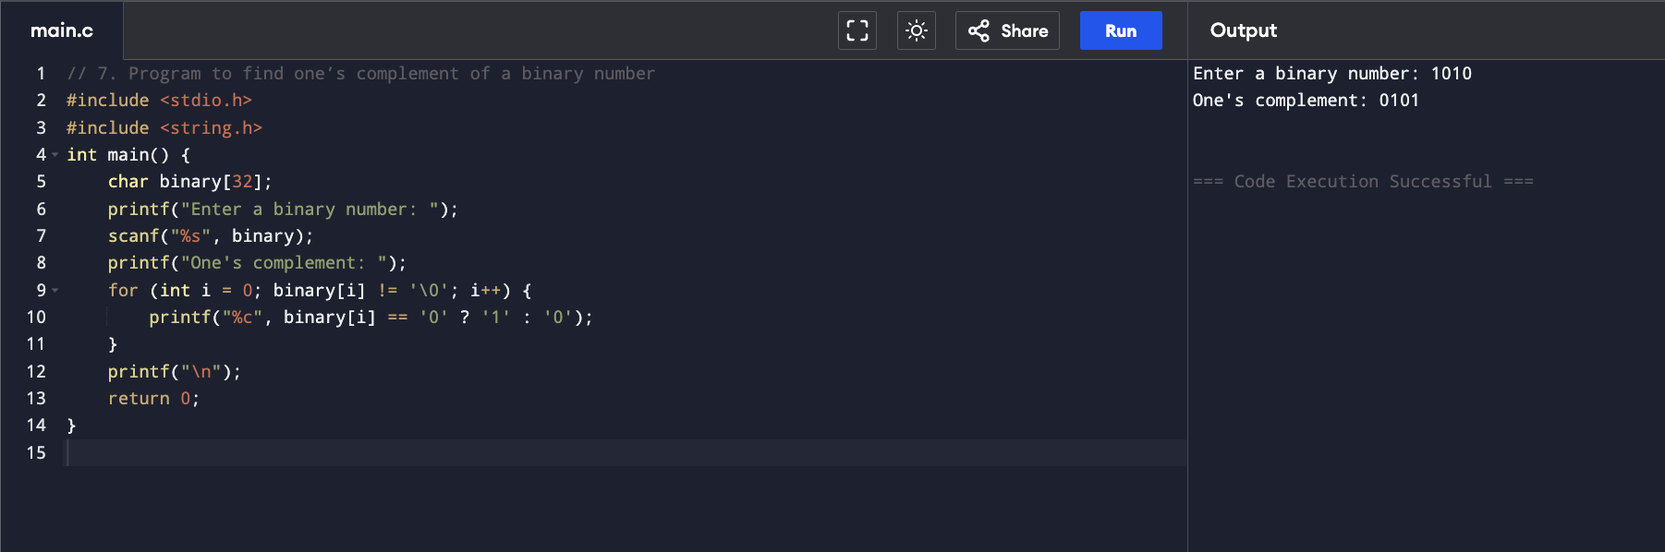

**8. Program to find two’s complement of a binary number**

#include <stdio.h>

#include <string.h>

int main() {

char binary[32], ones[32];

int len, carry = 1;

printf("Enter a binary number: ");

scanf("%s", binary);

len = strlen(binary);

for (int i = 0; i < len; i++) {

ones[i] = binary[i] == '0' ? '1' : '0';

}

ones[len] = '\0';

for (int i = len - 1; i >= 0; i--) {

if (ones[i] == '1' && carry == 1) {

ones[i] = '0';

} else if (carry == 1) {

ones[i] = '1';

carry = 0;

}

}

printf("Two's complement: %s\n", ones);

return 0;

}

**Output:**

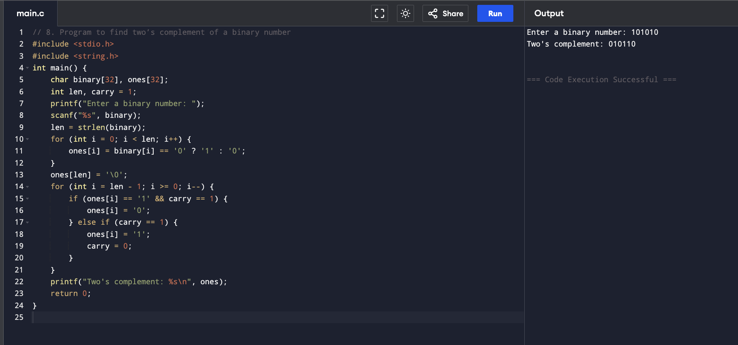

**9. Program to convert Decimal to Hexadecimal number system**

#include <stdio.h>

int main() {

int num;

printf("Enter a decimal number: ");

scanf("%d", &num);

printf("Hexadecimal: %X\n", num);

return 0;

}

**Output:**

